**BLOOD BANK SYSTEM**

**Initial entities**

**1. Donor**

**2. Blood**

**3. Receptionist**

**4. Blood Bank**

**5. Blood Bank Manager**

**6. Hospital**

**Relationship between entities:**

**1.A donor may donate blood any number of times. So cardinality is 1:N.**

**2.Many donors may register blood donation with a single receptionist. So cardinality is N:1.**

**3.Blood of different type in large numbers is stored in a single Blood Bank . So cardinality is N:1.**

**4.Blood Bank is managed by an blood bank -manager. So cardinality is 1:1.**

**5. A receptionist works in a Blood Bank . So cardinality is 1:1.**

**6. Hospitals may order blood from different Blood Banks . So cardinality is N:M.**

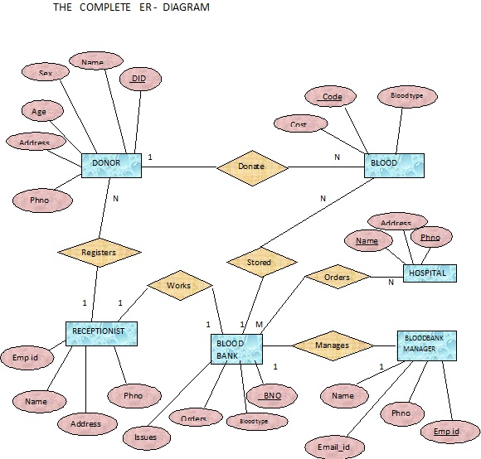

**Schema for blood bank system**

1.Donar( DID , Name , age , Address , phno , Sex , Receptionist_empid );

2.Blood( Code , Cost , Bloodtype , Donar , BloodBank_BNO);

3.Receptionist(name , empid , email_id , phno , BloodBank_BNO);

4.BloodBank(BNO , Bloodtype , orders , issues );

5.Hospital(name , phno , address);

6.BloodBankManager(empid , phno , Name , email_id , BloodBank_BNO);

7.BloodBank_has_Hospital(BloodBank_BNO , Hospital_name , Hospital_phno)

System generated ERdiagram

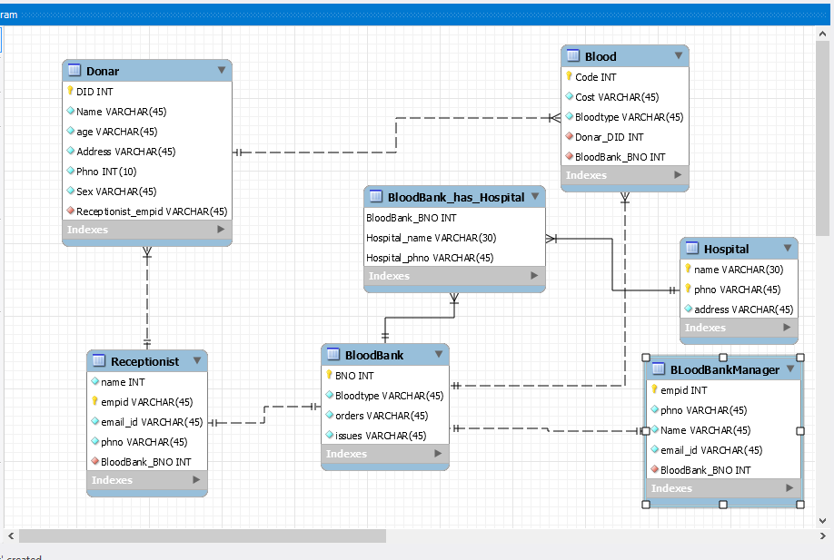 **CREATE STATEMENTS**

create database blood_bank;

use blood_bank;

CREATE TABLE IF NOT EXISTS `blood_bank`.`BloodBank` (

`BNO` INT NOT NULL,

`Bloodtype` VARCHAR(45) NOT NULL,

`orders` VARCHAR(45) NOT NULL,

`issues` VARCHAR(45) NOT NULL,

PRIMARY KEY (`BNO`));

CREATE TABLE IF NOT EXISTS `blood_bank`.`Receptionist` (

`empid` INT NOT NULL,

`name` VARCHAR(45) NOT NULL,

`email_id` VARCHAR(45) NOT NULL,

`phno` VARCHAR(45) NOT NULL,

`BloodBank_BNO` INT NOT NULL,

PRIMARY KEY (`empid`),

FOREIGN KEY (`BloodBank_BNO`)

REFERENCES `blood_bank`.`BloodBank` (`BNO`)

ON DELETE NO ACTION

ON UPDATE NO ACTION);

CREATE TABLE IF NOT EXISTS `blood_bank`.`Donar` (

`DID` INT NOT NULL,

`Name` VARCHAR(45) NOT NULL,

`age` VARCHAR(45) NOT NULL,

`Address` VARCHAR(45) NOT NULL,

`Phno` INT(10) NOT NULL,

`Sex` VARCHAR(45) NOT NULL,

`Receptionist_empid` int NOT NULL,

PRIMARY KEY (`DID`),

FOREIGN KEY (`Receptionist_empid`)

REFERENCES `blood_bank`.`Receptionist` (`empid`)

ON DELETE NO ACTION

ON UPDATE NO ACTION);

CREATE TABLE IF NOT EXISTS `blood_bank`.`Blood` (

`Code` INT NOT NULL,

`Cost` VARCHAR(45) NOT NULL,

`Bloodtype` VARCHAR(45) NOT NULL,

`Donar_DID` INT NOT NULL,

`BloodBank_BNO` INT NOT NULL,

PRIMARY KEY (`Code`),

FOREIGN KEY (`Donar_DID`)

REFERENCES `blood_bank`.`Donar` (`DID`)

ON DELETE NO ACTION

ON UPDATE NO ACTION,

FOREIGN KEY (`BloodBank_BNO`)

REFERENCES `blood_bank`.`BloodBank` (`BNO`)

ON DELETE NO ACTION

ON UPDATE NO ACTION);

CREATE TABLE IF NOT EXISTS `blood_bank`.`BLoodBankManager` (

`empid` INT NOT NULL,

`phno` VARCHAR(45) NOT NULL,

`Name` VARCHAR(45) NOT NULL,

`email_id` VARCHAR(45) NOT NULL,

`BloodBank_BNO` INT NOT NULL,

PRIMARY KEY (`empid`),

FOREIGN KEY (`BloodBank_BNO`)

REFERENCES `blood_bank`.`BloodBank` (`BNO`)

ON DELETE NO ACTION

ON UPDATE NO ACTION);

CREATE TABLE IF NOT EXISTS `blood_bank`.`Hospital` (

`name` VARCHAR(30) NOT NULL,

`phno` VARCHAR(45) NOT NULL,

`address` VARCHAR(45) NOT NULL,

PRIMARY KEY (`name`, `phno`));

CREATE TABLE IF NOT EXISTS `blood_bank`.`BloodBank_has_Hospital` (

`BloodBank_BNO` INT NOT NULL,

`Hospital_name` VARCHAR(30) NOT NULL,

`Hospital_phno` VARCHAR(45) NOT NULL,

PRIMARY KEY (`BloodBank_BNO`, `Hospital_name`, `Hospital_phno`),

FOREIGN KEY (`BloodBank_BNO`)

REFERENCES `blood_bank`.`BloodBank` (`BNO`)

ON DELETE NO ACTION

ON UPDATE NO ACTION,

FOREIGN KEY (`Hospital_name` , `Hospital_phno`)

REFERENCES `blood_bank`.`Hospital` (`name` , `phno`)

ON DELETE NO ACTION

ON UPDATE NO ACTION);